Lab: Add a New Host to the Cluster

|  |  |
| --- | --- |
| **Objective:** | Add an additional node to a cluster. |
| **Successful Outcome:** | **hadoop-slave** will be added to your Hadoop cluster as a DataNode. |
| **Before You Begin:** | Your 3-node cluster should have Hadoop successfully installed. |

NOTE: this lab includes RESIZE of Hadoop Docker clusters

1. Login to Ambari
   1. If you are not logged in already, login to the Ambari Dashboard of your cluster at [localhost]:8080.
2. Run the Add Hosts Wizard
   1. Click on the Hosts tab of Ambari.
   2. Click on the Action Dropdown and choose Add New Hosts option to start the Add Host Wizard:

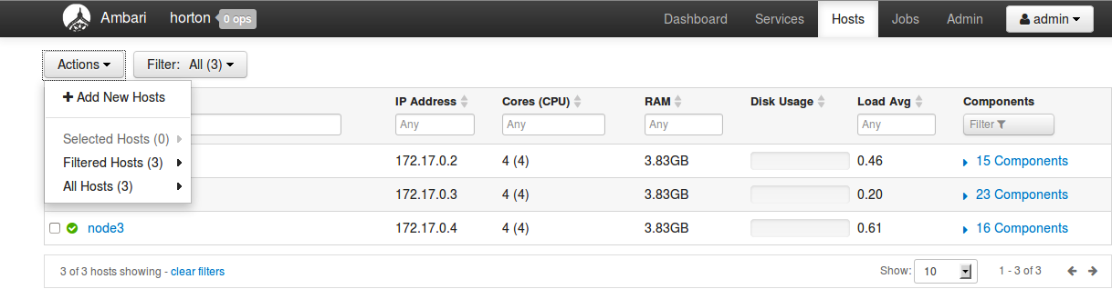

1. Complete the Add Host Wizard
   1. You have seen this wizard before when you installed HDP, so we will provide only a few hints in this lab. Read through the following hints before running the wizard.
   2. The hostname of the node you are adding is node4.
   3. On the Assign Slaves and Clients step, choose only the Client option.
2. Verify the New Host
   1. Go to the Hosts page of Ambari. You should see all four of your nodes now listed.

**RESULT**: You have added a new node to the cluster and Hadoop is installed on it. In a later lab, you will commission this node as a DataNode.